Project 1 Report

Group #9

Zhengyang Tang, Li Zhu, Jiayi Xu, Zhuolin Yang

**3. Loading map**

We load the file and parse it into a map using

#attention: load sna first, then load igraph

#read data,need to set working directory first

edges1 <- read.table('roadNet-CA.txt')

em <- as.matrix(edges1) #save data in matrix

v1 <- em[,1] #Save the first column of data to v1

v2 <- em[,2] #Save the second column of data to v2

relations <- data.frame(from=v1,to=v2)

g<-graph.data.frame(relations,directed=TRUE)

Now g is our graph

**\* Map size reduction**

Firstly, we tried to reduce the map size by the method in the announcement. We deleted vertices with degree lower than or equal to certain number k.

The map size is acceptable when k is 10.

g <- g - V(g)[degree(g)<=10]

There were 2094 vertices and 184 edges left. Apparently, this method of map size reduction is not good since the graph is much too sparse after reduction. We decided to try another method.

Since deleting vertices with certain degree will result in drop of degree of vertices not being deleted and kept most of the remaining vertices connected, we tried to iteratively delete vertices with a very low degree. (here we delete vertices with degree lower than or equals to 4)

i <- 0

while(vcount(g)>5000){

g <- g - V(g)[igraph::degree(g)<=4]

i <- i+1

}

We keep deleting vertices whose degree lower or equals to 4 until there are less than 5000 of them remains. (graph with 5000 nodes is properly small for plotting) It takes 56 iterations to reduce the map size. Now the map has 4947 vertices and 16382 edges. This method is obviously better than the previous one.

* if we keep the loop running, the number of vertices left will converge to a number between 4000 and 5000.

**Plotting**

plot(g)

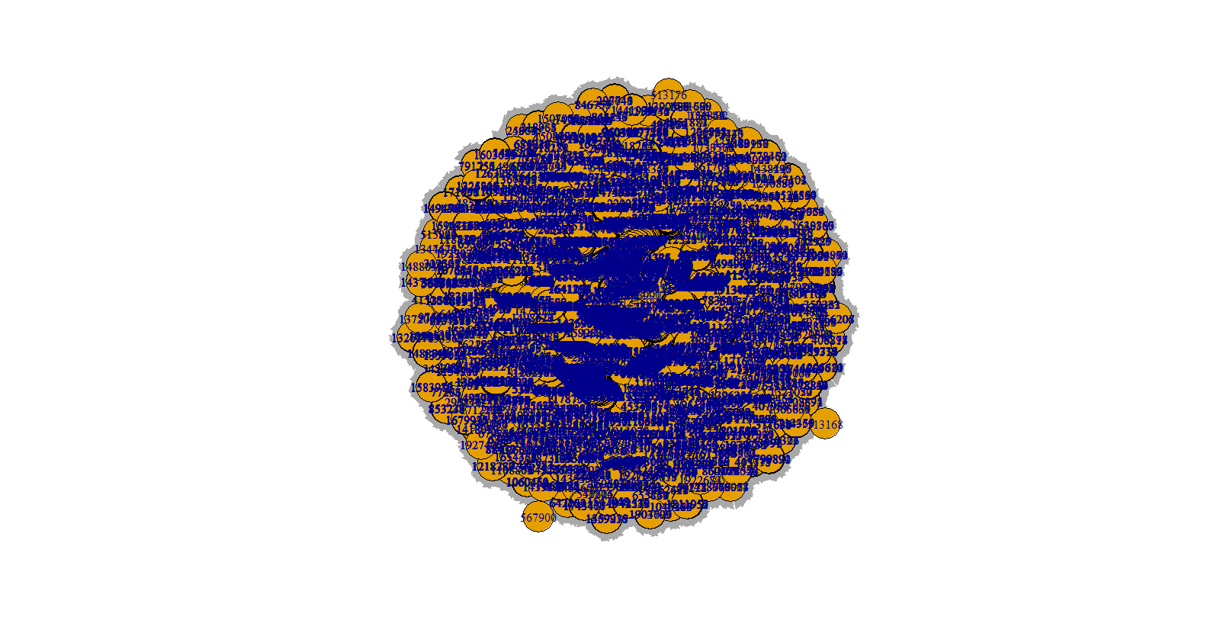

**4. Experiment with 10 functions shown in the lecture notes and associated PPT file**

1) is.connected(g)

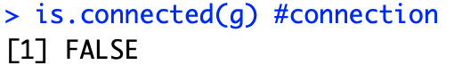

This function decides whether the graph is connected. The result is “False ” in our project. Because after our graph reducing, there are some vertices are not connected to any other vertices.

2) connectedness(graph.matrix)



This function shows the connectedness of the graph, which is the fraction of all dyads (e.g., two nodes, u and v) such that there exists an undirected path from u to v.

3) density <- gden(graph.matrix)

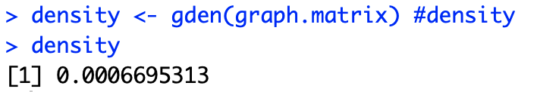

This function computes the density of the graph, which is here taken to be the number of existing edges divided by the number of possible edges.

4) shortpath <- geodist(graph.matrix)

View(shortpath)

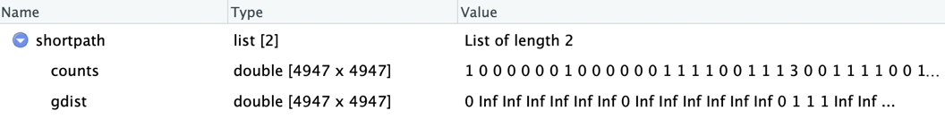

This function calculates the shortest path between any two nodes inside the network.

5) ego <- ego.extract(graph.matrix)

View(ego)

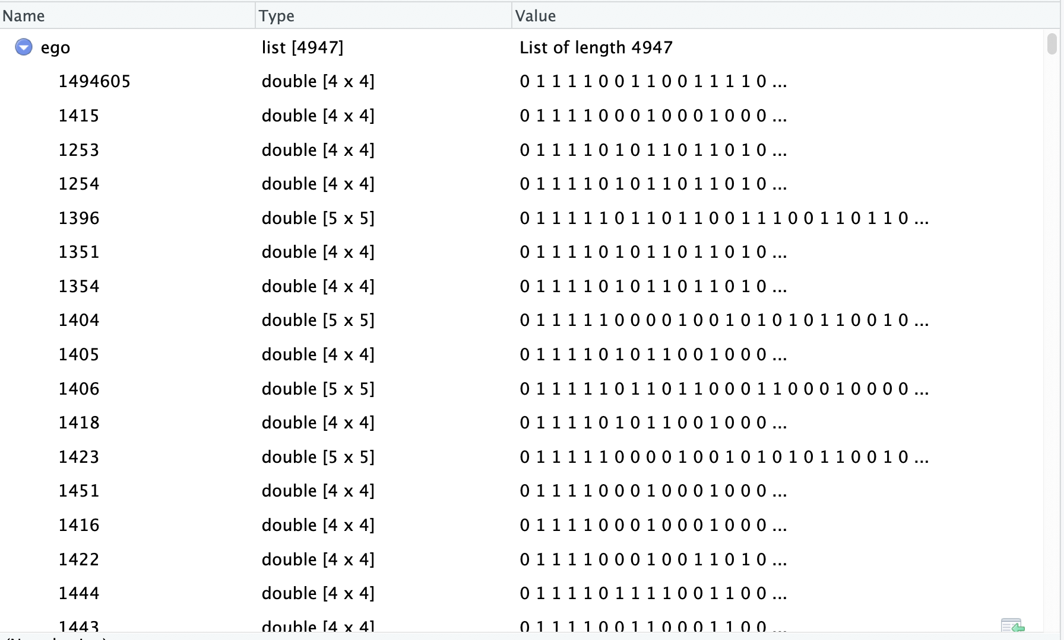

This function takes the input graph and returns a list containing the egocentric networks centered on vertices, and using adjacency rule neighborhood to define inclusion.

egocentric <- ego[2]

View(egocentric)

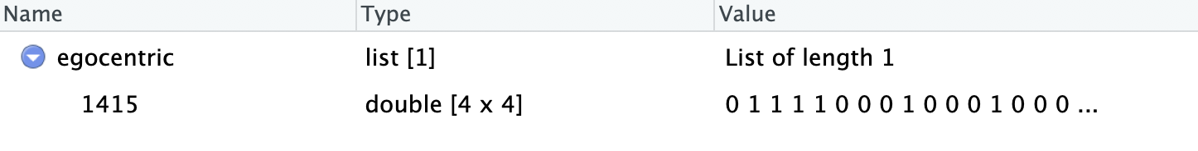

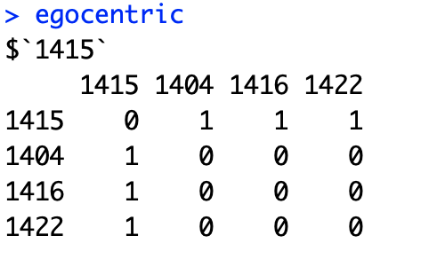

An egocentric network of a vertex is a subgraph consisting of the vertex and its immediate neighbors.

6) closeness(g)

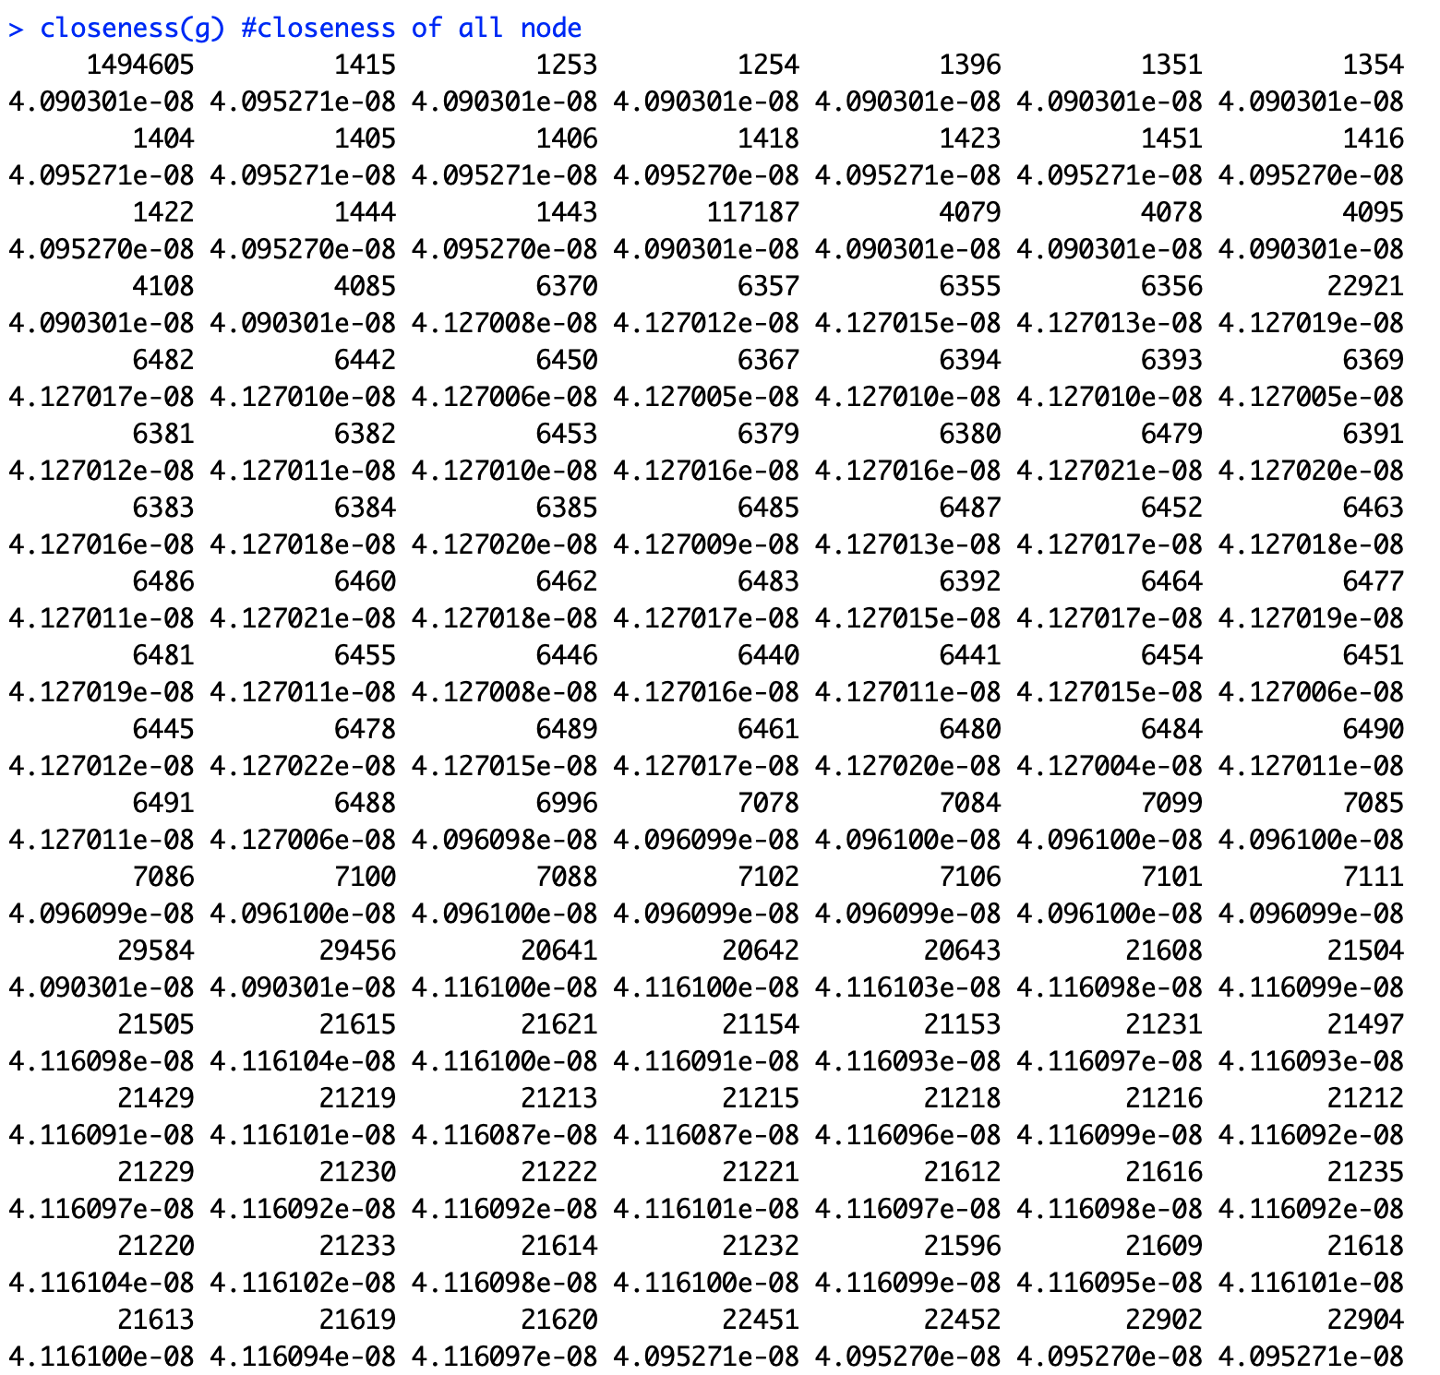

This function calculates the closeness of all nodes, which is the ratio of the total number of nodes in the graph minus one to the sum of the geodesics from v to every other vertex in the graph.

7) vertex_attr(g)

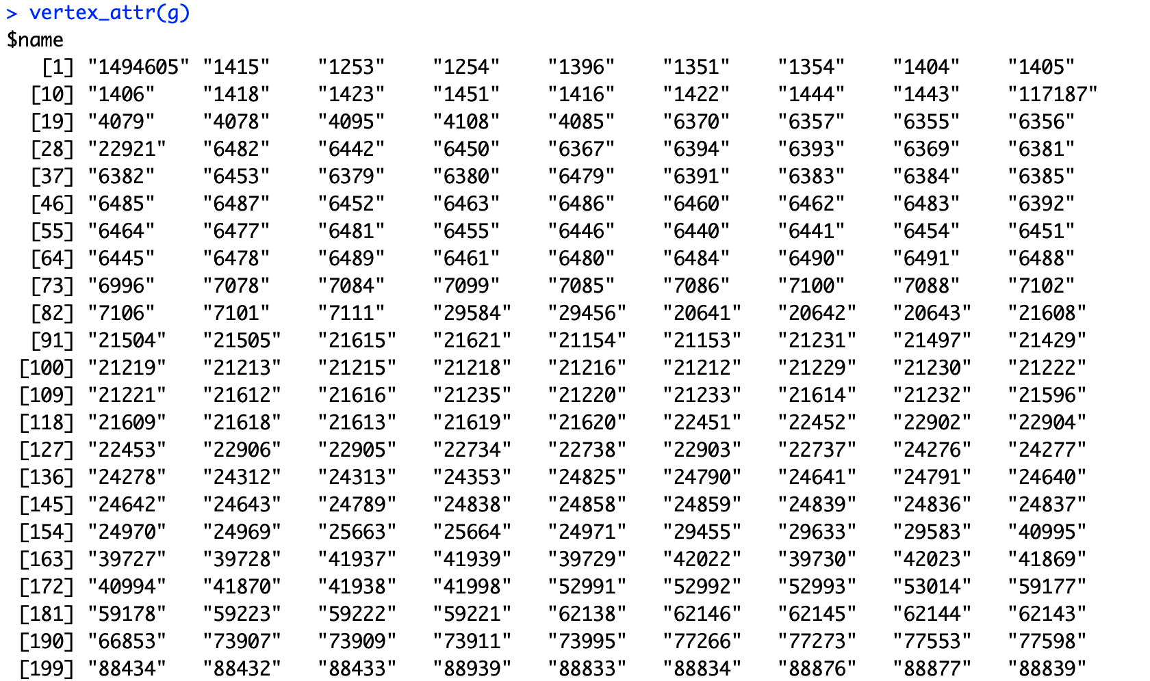

This function query the attributes of vertexes in the graph.

8) is.simple(g)

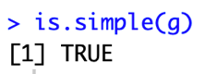

This function checks whether the graph is simple. In this case, it returns TRUE means that the graph does not contain loop edges and multiple edges.

9) page_rank(g)

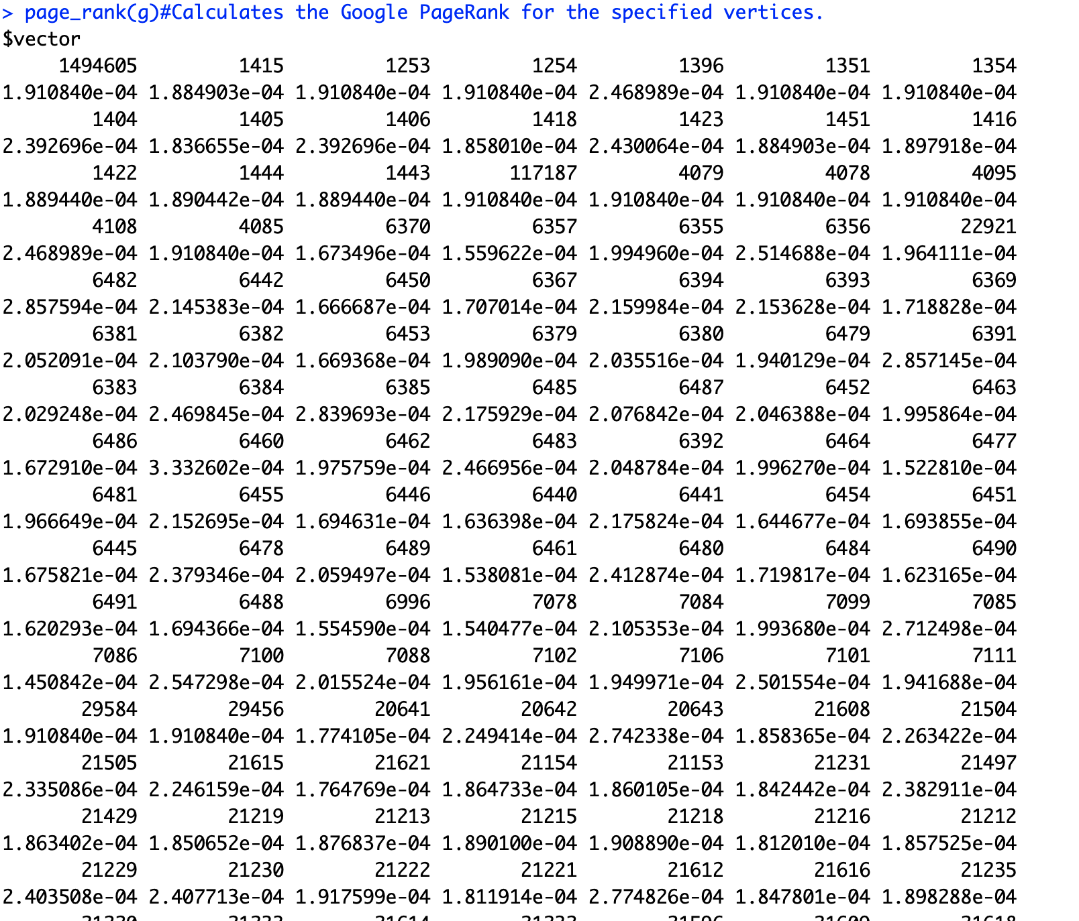

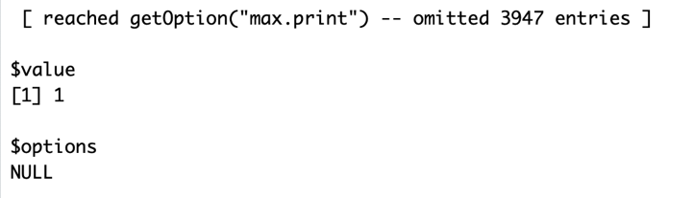

This function calculates the Google PageRank for vertices.

10) centr_betw(g)

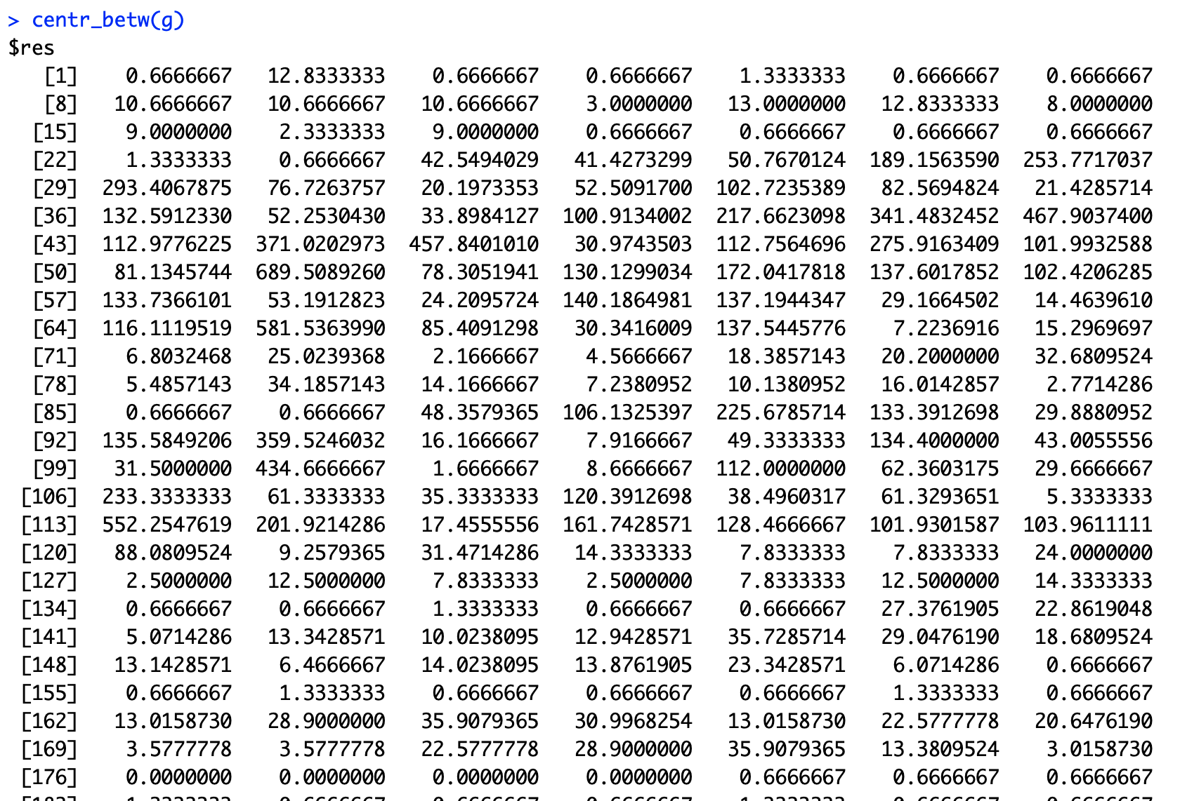

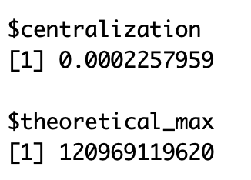

This function centralizes the graph according to the betweenness of vertices.

**5. #15 other functions in igraph**

bipartite.mapping(g)

cliques(g)

centralization.betweenness(g)

centralization.closeness(g)

articulation.points(g)

average.path.length(g)

automorphisms(g

blockGraphs(g)

cohesion(g)

coreness(g)

efficiency(graph.matrix)

gtrans(graph.matrix)

isolates(graph.matrix)

loadcent(graph.matrix)

g.reach<-reachability(graph.matrix)

stresscent(graph.matrix)

1)bipartite.mapping(g)

decide whether a graph is bipartite

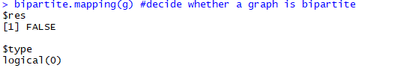

2) cliques(g)

The functions find cliques

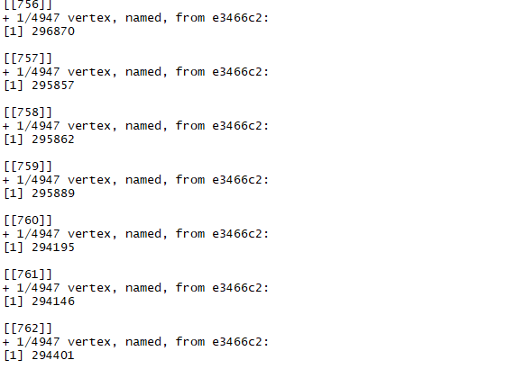

3-4) centralization.betweenness(g)

Centralize a graph according to the betweenness of vertices

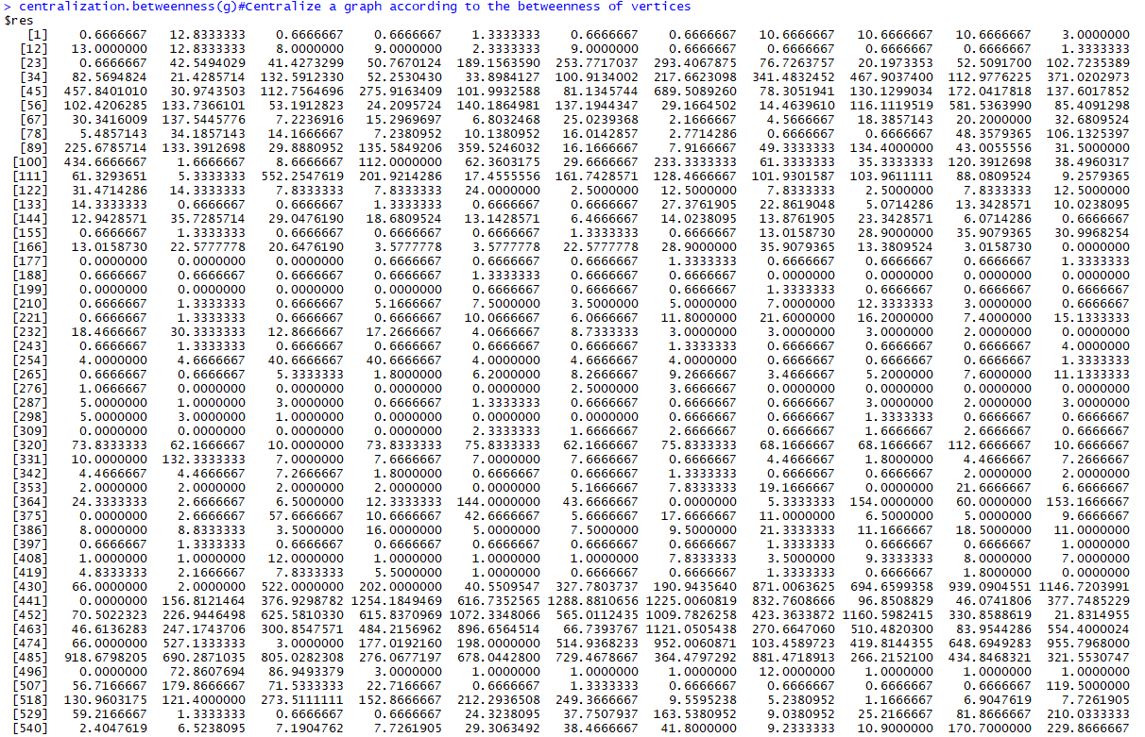

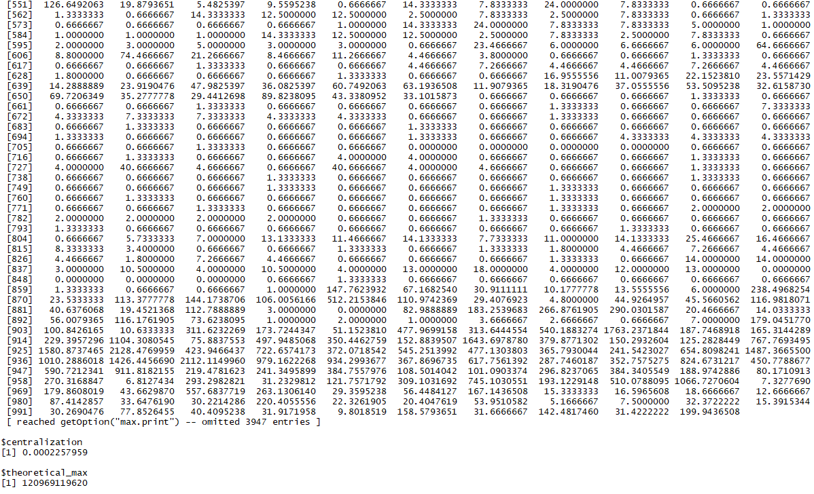

centralization.closeness(g)

Centralize a graph according to the closeness of vertices

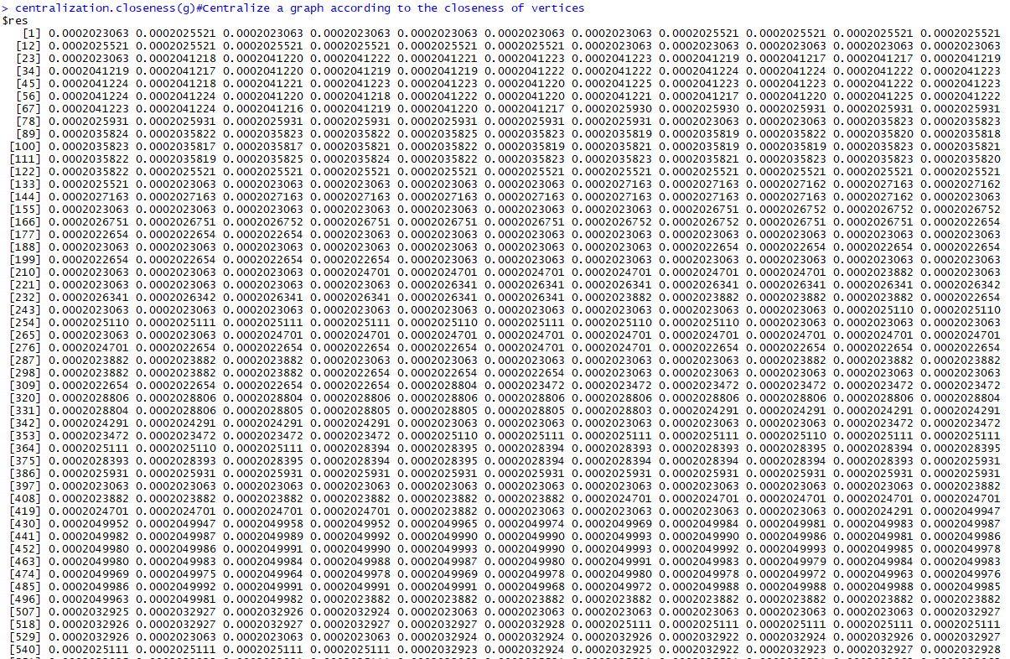

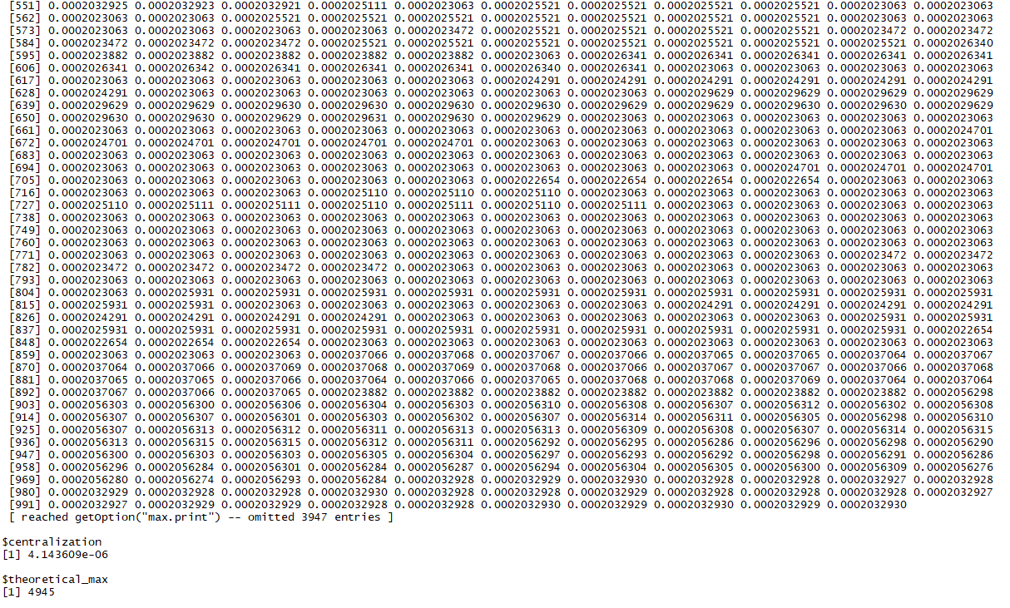

5) articulation.points(g)

Articulation points of a graph



6) average.path.length(g)

Shortest (directed or undirected) paths between vertices



7) automorphisms(g)

Number of automorphisms

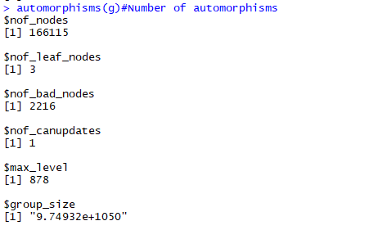

8) blockGraphs(g)

Calculate Cohesive Blocks



9) cohesion(g)

Vertex connectivity



10) coreness(g)

The k-core of graph is a maximal subgraph in which each vertex has at least degree k. The coreness of a vertex is k if it belongs to the k-core but not to the (k+1)-core.

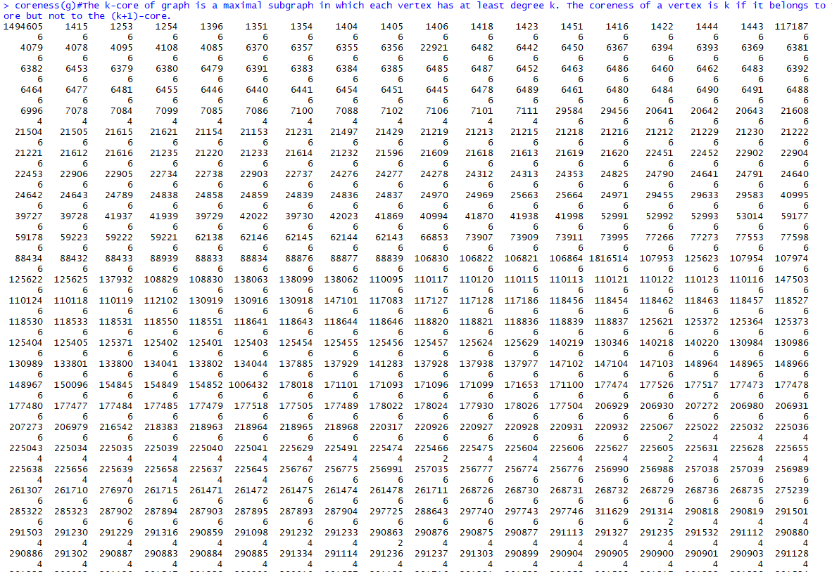

11) efficiency(graph.matrix)

Compute Graph Efficiency Scores



12) gtrans(graph.matrix)

Compute the Transitivity of an Input Graph or Graph Stack



13) isolates(graph.matrix)

List the Isolates in a Graph or Graph Stack



14) loadcent(graph.matrix)

Compute the Load Centrality Scores of Network Positions

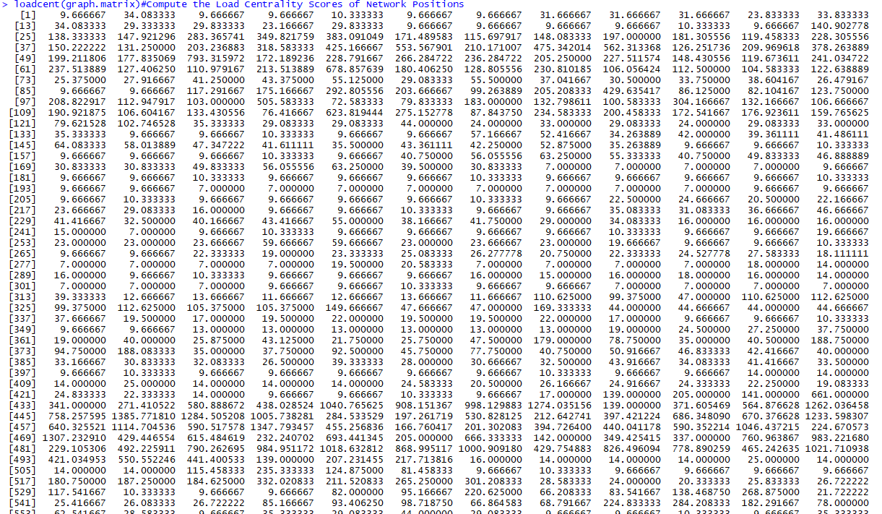

15) g.reach<-reachability(graph.matrix)

producing the associated reachability matrices

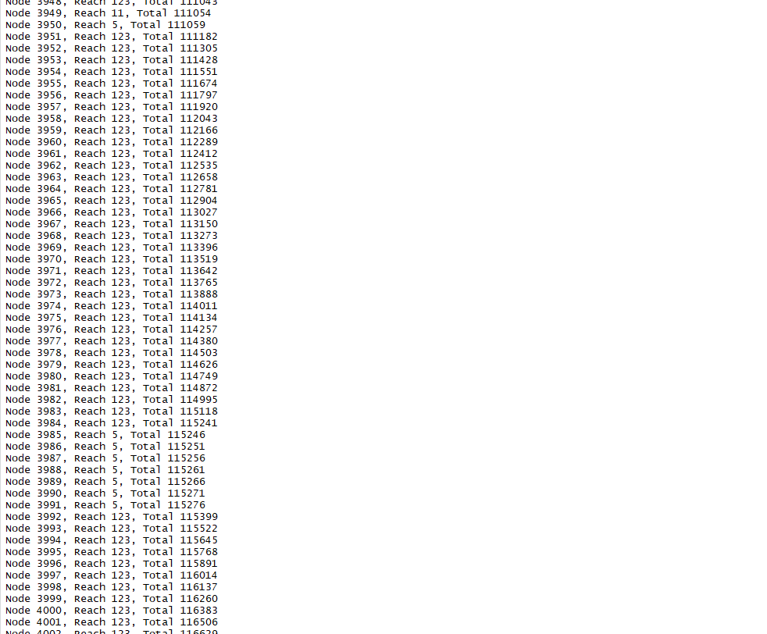

16) stresscent(graph.matrix)

Compute the Stress Centrality Scores of Network Positions

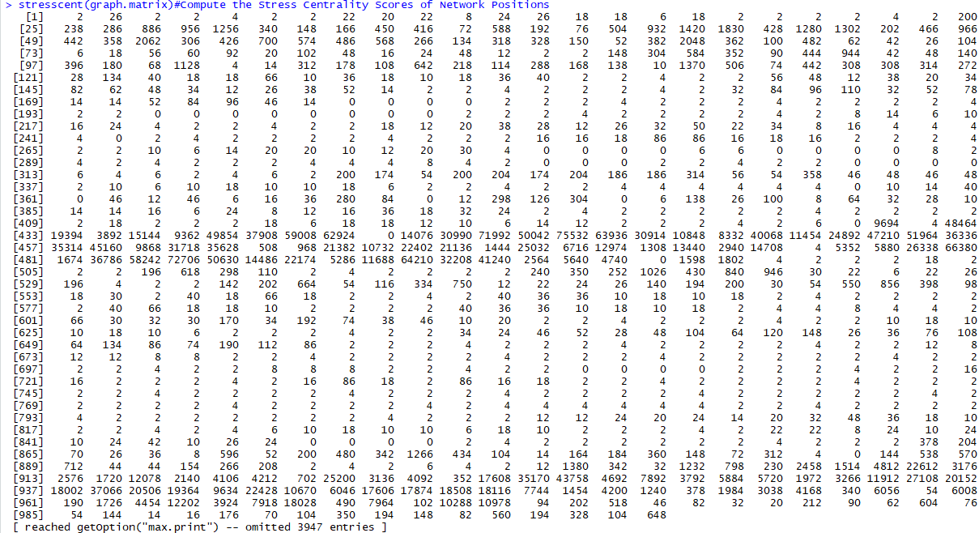

6.Determine the (a) central person(s) in the graph, (b) longest path, (c) largest clique, (d) ego, and (e) betweenness centrality and power centrality.

1. Is there more than one person with the most degrees?

There is only one person with the most degree: The No.534751 vertice with 20 degree.

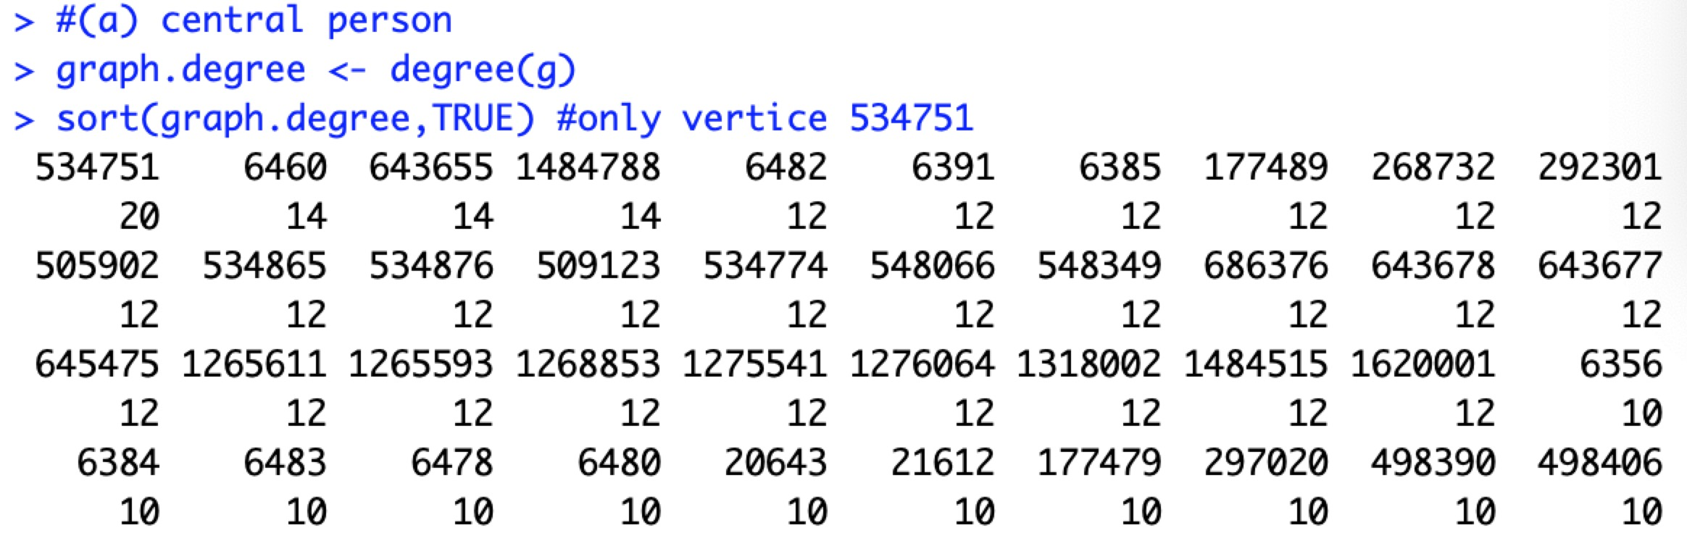

b. Are there multiple longest paths?

c. Are there multiple cliques?

There are multiple largest cliques in the graph. The clique size is 4.

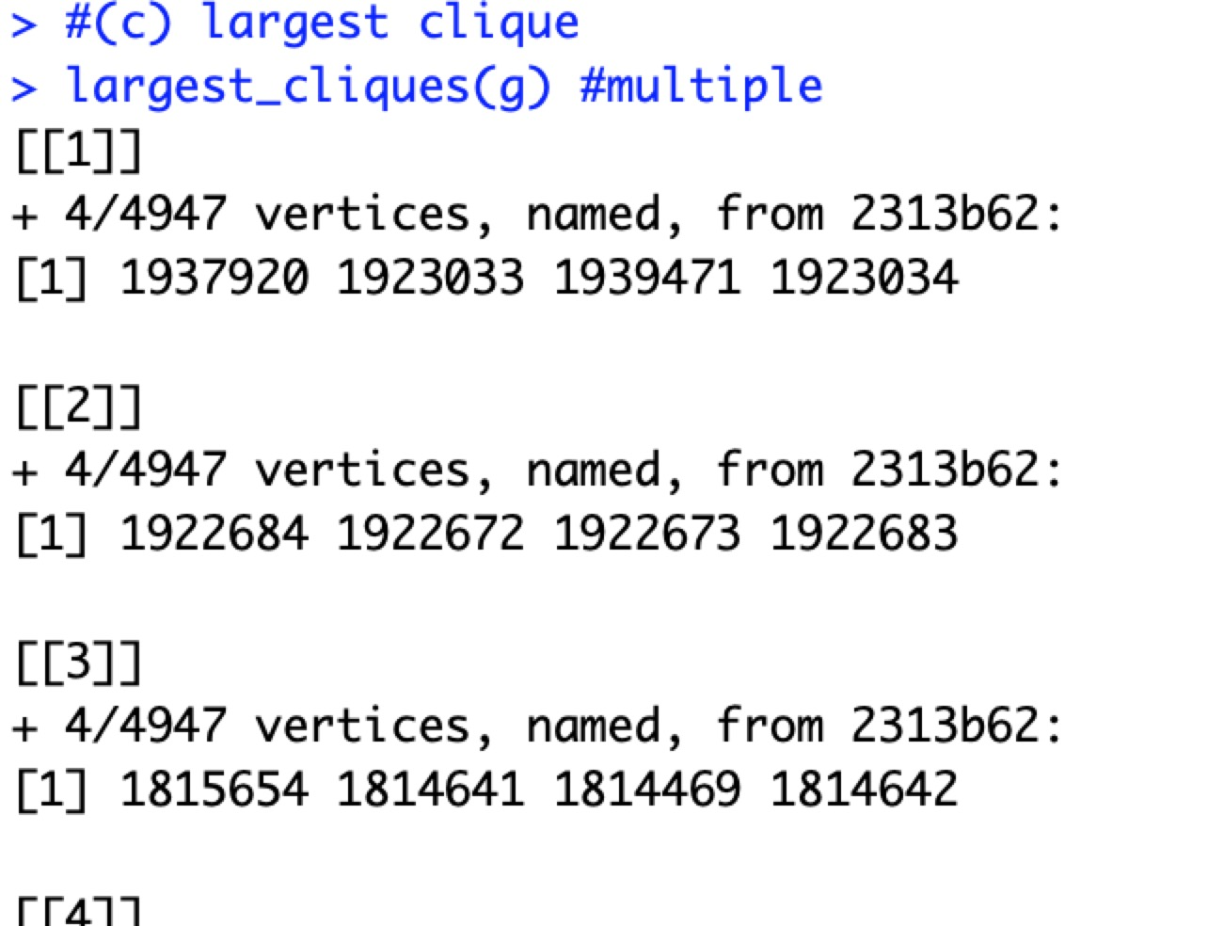

d. Are there more than one person with the highest ego?

There is only one person with the highest ego size 11.

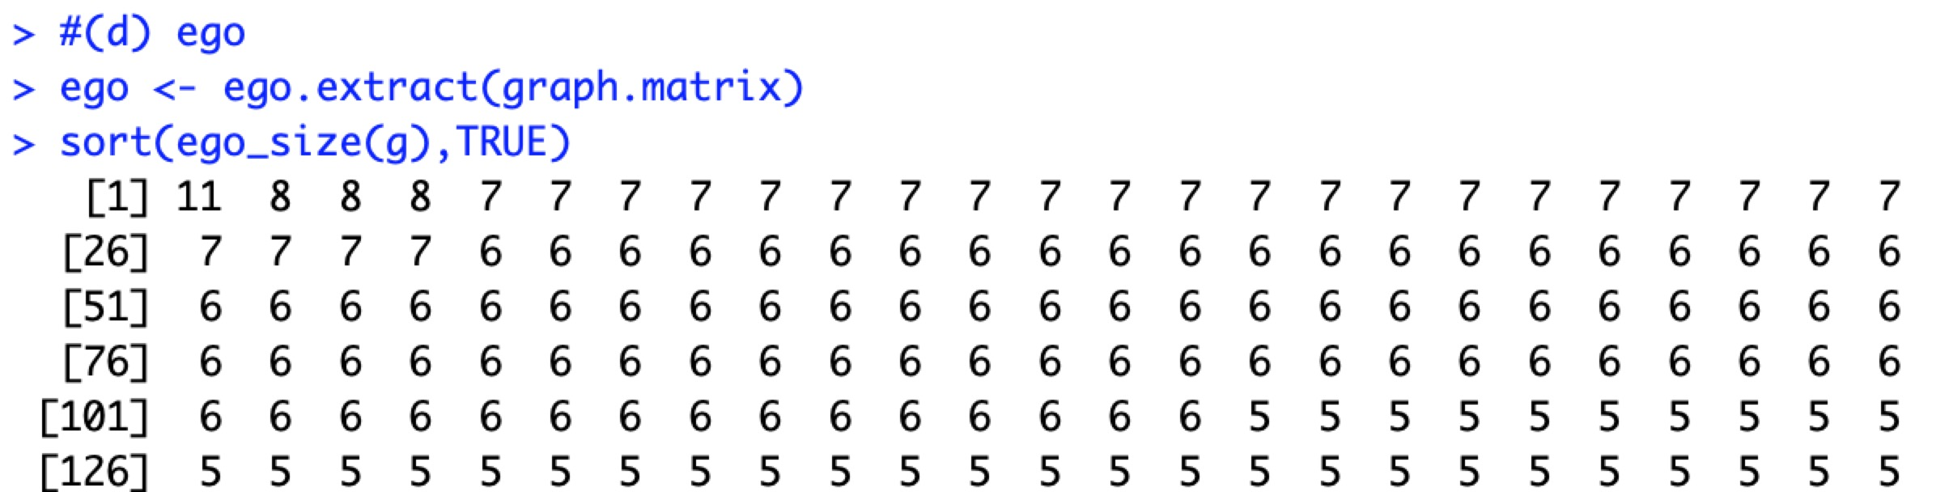

e. What is the difference in betweenness centrality vs. power centrality for the cases you find? Consider comparing the nodes that are members of each set. Are there common nodes?

Betweenness is a centrality measure of a vertex within a graph. Betweenness centrality quantifies the number of times a node acts as a bridge along the shortest path between two other nodes.

Power centrality's definition is that each node's centrality is the sum of the centrality values of the nodes that it is connected to. So people who are tied to very central persons should have higher centrality than those who are not.

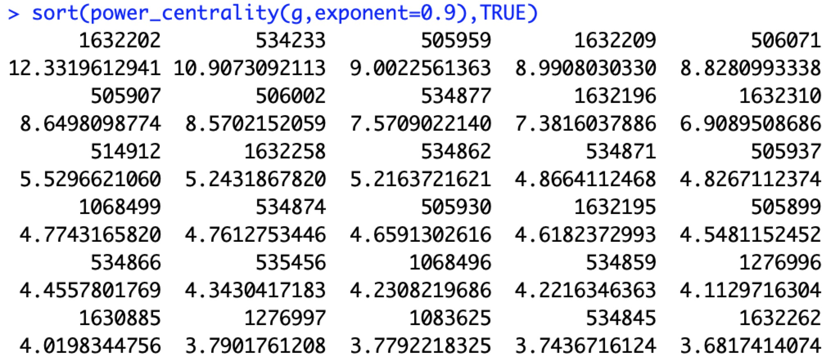

7.

Step 1: find number of all nodes of order 0 to 3 for all nodes

vc<-ego_size(g, 3, V(g),mindist = 0)

step 2: order the number of 3-reachable nodes for each nodes, and select top 20 indexes of them

od are the indexes of target nodes

od<-order(vc,decreasing = TRUE)[1:20]

step 3: create list of 3-reachable nodes of each nodes

V(g)[c(od)] is the vertices of each index in od

topGraphs <- ego(g, 3, V(g)[c(od)],mindist = 0)

step 4: iterate through each pair of list of nodes, and find their intersections

for(i in 1:19){

for(j in i:20){

print(intersect(topGraphs[i], topGraphs[j]))

}

}

The result indicates there are 19 pair of 3-reachable nodes have intersection.

